THE CORRELATION BETWEEN INTENSITY OF PLAYING MOBILE LEGENDS GAME AND VOCABULARY MASTERY OF THE ENGLISH DEPARTMENT STUDENTS OF IAIN PALANGKA RAYA

THESIS

BY:
SANDY WINATA
NIM 1401120944

STATE ISLAMIC INSTUTUTE OF PALANGKA RAYA
FACULTY OF TEACHER TRAINING AND EDUCATION
DEPARTMENT OF LANGUAGE EDUCATION
STUDY PROGRAM OF ENGLISH EDUCATION
2021 M/ 1442 H
THE CORRELATION BETWEEN INTENSITY OF PLAYING MOBILE LEGENDS GAME AND VOCABULARY MASTERY OF THE ENGLISH DEPARTMENT STUDENTS OF IAIN PALANGKA RAYA

THESIS
Presented to
State Islamic Institute of Palangka Raya
In partial fulfillment of the requirements
For the degree of Sarjana in English Language Education

BY:
SANDY WINATA
NIM 1401120944

STATE ISLAMIC INSTUTUTE OF PALANGKA RAYA
FACULTY OF TEACHER TRAINING AND EDUCATION
DEPARTMENT OF LANGUAGE EDUCATION
STUDY PROGRAM OF ENGLISH EDUCATION
2021 M/ 1442 H

ADVISOR APPROVAL
Thesis Title : THE CORRELATION BETWEEN INTENSITY OF PLAYING MOBILE LEGENDS GAME AND VOCABULARY MASTERY OF THE ENGLISH DEPARTMENT STUDENTS OF IAIN PALANGKA RAYA
Name : Sandy Winata
SRN : 1401120944
Faculty : Teacher Training and Education
Department : Language Education
Study Program : English Education

This is to certify that the thesis has been approved by the thesis advisors for Thesis Examination/Munaqasah by the Board of Examiners of the Faculty of Teacher Training and Education of the State Islamic Institute of Palangka Raya.

Palangka Raya, May 04th 2021
Advisor I,  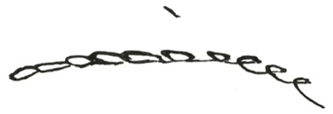  M. Zaini Miftah, M. Pd.  NIP. 19750915 200912 1 002 | 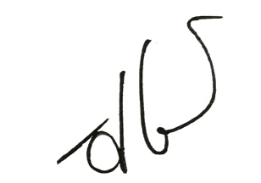  Advisor II,  Aris Sugianto, M. Pd.  NIP. 19830819 201503 1 001

Acknowledged by:
Vice Dean in Academic Affairs,  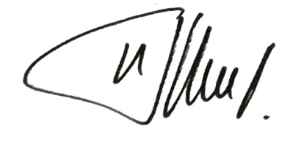  Dra. Nurul Wahdah, M. Pd  ORN. 19800307 200604 2 004 | Secretary  Departement of Language Education  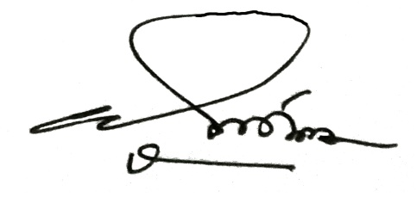  Akhmad Ali Mirza, M. Pd  ORN. 198406 201503 1 003

PERSETUJUAN SKRIPSI

Judul Skripsi | : | : THE CORRELATION BETWEEN INTENSITY OF PLAYING MOBILE LEGENDS GAME AND VOCABULARY MASTERY OF THE ENGLISH DEPARTMENT STUDENTS OF IAIN PALANGKA RAYA
Nama | : | : Sandy Winata
NIM | : | : 1401120944
Fakultas | : | : Tarbiyah dan Ilmu Keguruan
Jurusan | : | : Pendidikan Bahasa
Program Studi | : | : Tadris Bahasa Inggris
Dengan ini menyatakan bahwa skripsi ini telah di setujui oleh pebimbing skripsi untuk disidangkan oleh Tim Penguji Skripsi Fakultas Tarbiyah dan Ilmu Keguruan Institut Agama Islam Negeri Palangka Raya.
Palangka Raya, 04 Mei 2021
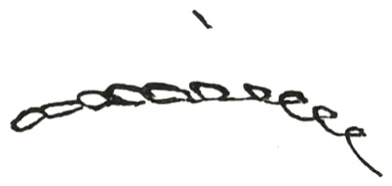  Pembimbing I  M. Zaini Miftah, M. Pd.  NIP. 19750915 200912 1 002 | Pembimbing II  Aris Sugianto, M. Pd.  NIP. 19830819 201503 1 001
Mengetahui,

Wakil Dekan Bidang Akademik  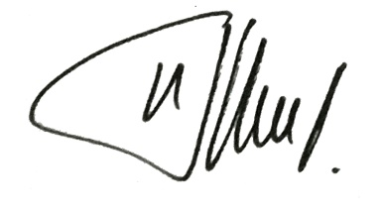  Dra. Nurul Wahdah, M. Pd.  NIP. 19800307 200604 2 004 | Sekretaris,  Jurusan Pendidikan Bahasa  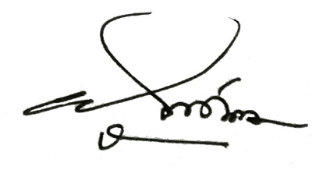  Akhmad Ali Mirza. M. Pd.  NIP. 19840622 201503 1 003

OFFICIAL NOTE

Palangka Raya, May 04th 2021
Case : Examination of
Sandy Winata’s Thesis
To
The Dean of Faculty of Teacher
Training and Education of State
Islamic Institute of Palangka Raya

In -
Palangka Raya

Assalamu’alaikum Wr. Wb.
By reading and analyzing of this thesis, we think the thesis in the name of:
Name : Sandy Winata
SRN : 1401120944
Thesis Title : THE CORRELATION BETWEEN INTENSITY OF PLAYING MOBILE LEGENDS GAME AND VOCABULARY MASTERY OF THE ENGLISH DEPARTMENT STUDENTS OF IAIN PALANGKA RAYA.
Can be examined in partial fulfillment of the requirements of the Degree of Sarjana Pendidikan in The Study Program of English Education of The Language Education of The Faculty of Education and Teacher Training of State Islamic Institute of Palangka Raya.
Thank you for the attention.
Wassalamu’alaikumWr. Wb.
Advisor I,  M. Zaini Miftah, M. Pd.  NIP. 19750915 200912 1 002 | Advisor II,  Aris Sugianto, M. Pd.  NIP. 19830819 201503 1 001
NOTA DINAS

Palangka Raya, 04 Mei 2021
Hal : Permohonan Ujian Skripsi
Sandy Winata
Kepada
Yth. Dekan Fakultas Tarbiyah dan
Ilmu Keguruan Institut Agama IslamNegeri Palangka Raya

Di -
Palangka Raya
Assalamu’alaikum Wr. Wb.
Setelah membaca, memeriksa dan mengadakan perbaikan seperlunya, maka kami berpendapat bahwa skripsi saudara:
Nama : Sandy Winata
NIM : 1401120944
JudulSkripsi : THE CORRELATION BETWEEN INTENSITY OF PLAYING MOBILE LEGENDS GAME AND VOCABULARY MASTERY OF THE ENGLISH DEPARTMENT STUDENTS OF IAIN PALANGKA RAYA
Sudah dapat diajukan untuk memperoleh gelar Sarjana Pendidikan pada Jurusan Pendidikan Bahasa Program Studi Tadris Bahasa Inggris IAIN Palangka Raya.
Demikian atas perhatiannya, diucapkan terima kasih.
Wassalamu’alaikum Wr. Wb.
Pembimbing I,  M. Zaini Miftah, M. Pd.  NIP. 19750915 200912 1 002 | Pembimbing II,  Aris Sugianto, M. Pd.  NIP. 19830819 201503 1 001

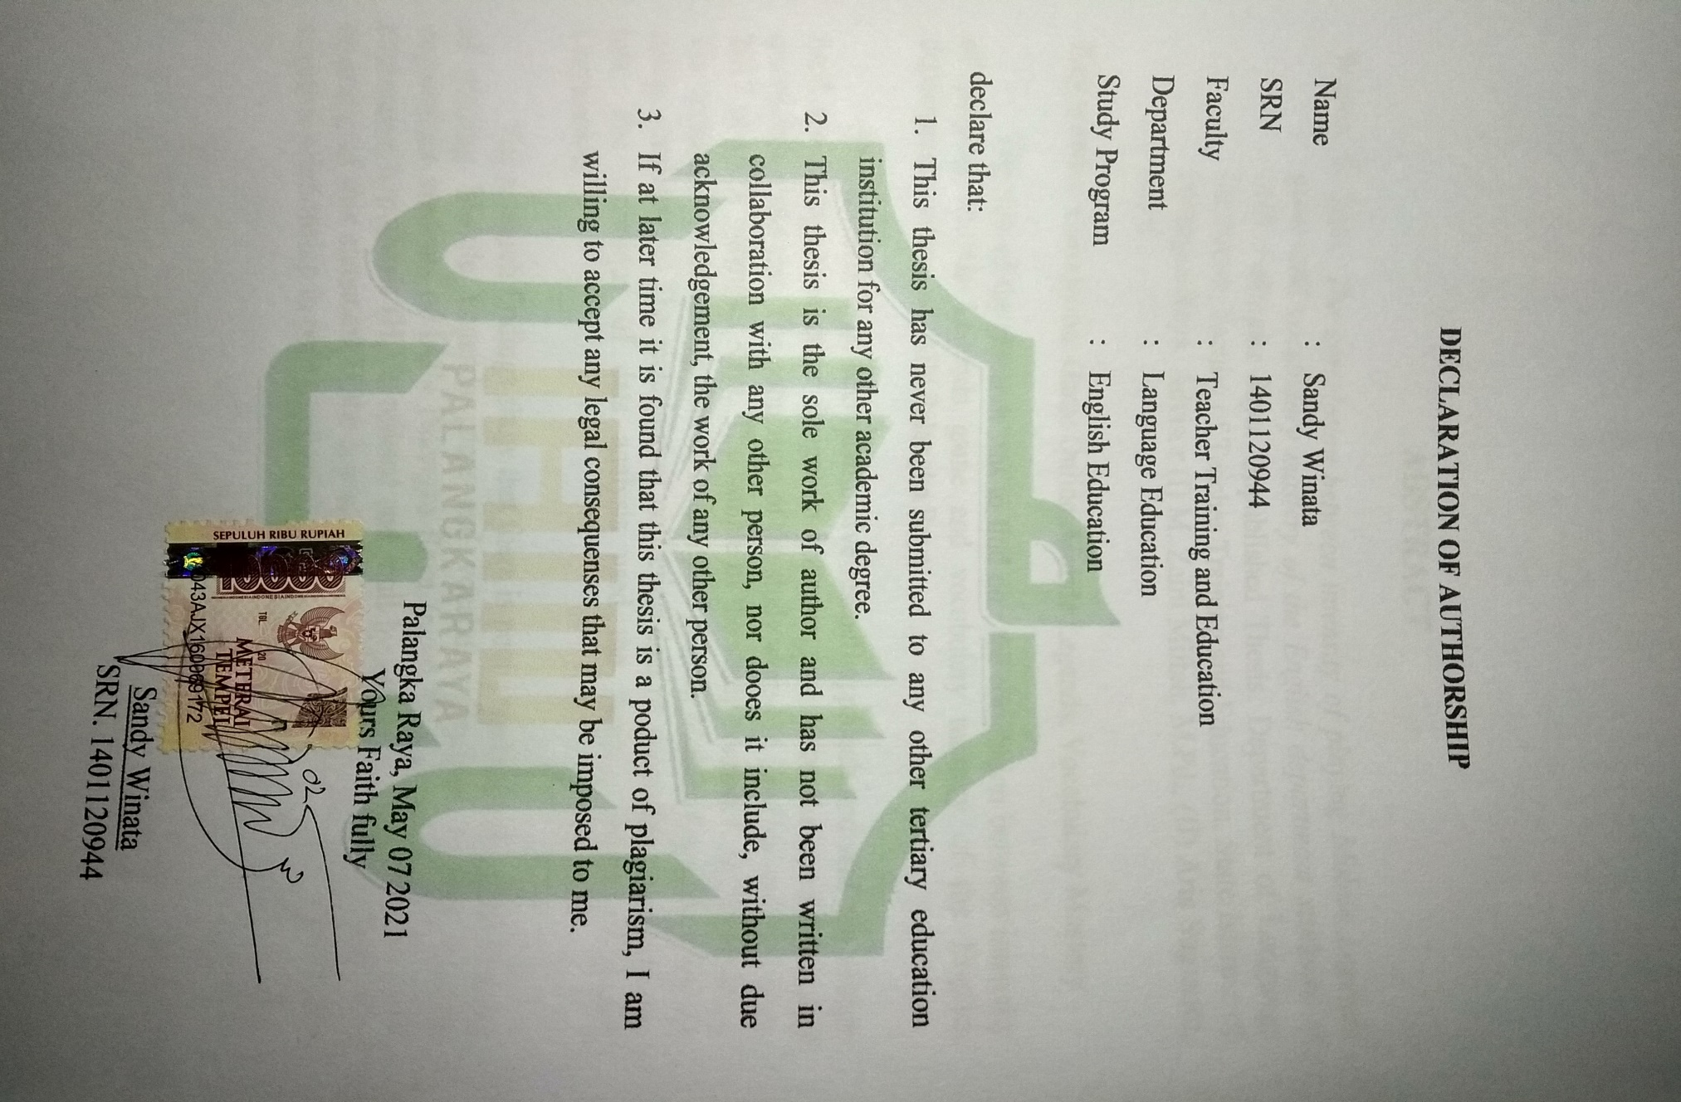

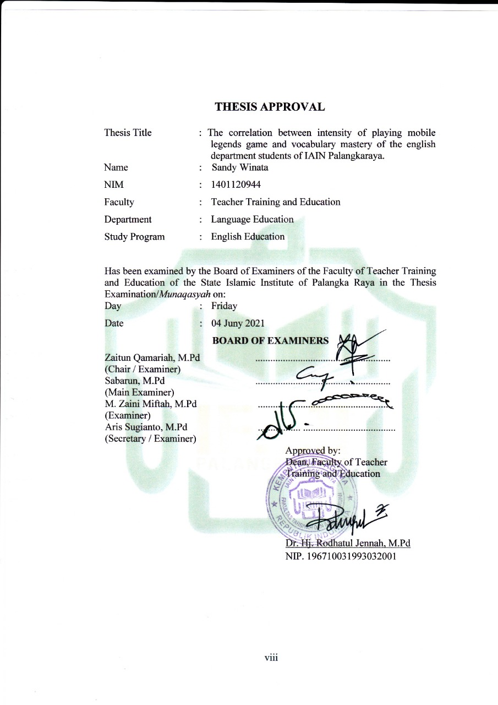
THESIS APPROVAL
Thesis Title : The correlation between intensity of playing mobile legends game and vocabulary mastery of the english department students of IAIN Palangkaraya.
Name : Sandy Winata
NIM : 1401120944
Faculty : Teacher Training and Education
Department : Language Education
Study Program : English Education

Has been examined by the Board of Examiners of the Faculty of Teacher Training and Education of the State Islamic Institute of Palangka Raya in the Thesis Examination/Munaqasyah on:
Day : Friday
Date : 04 Juny 2021
BOARD OF EXAMINERS
Zaitun Qamariah, M.Pd ......................................................
(Chair / Examiner)
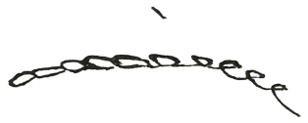
Sabarun, M.Pd ......................................................
(Main Examiner)
M. Zaini Miftah, M.Pd ......................................................
(Examiner)
Aris Sugianto, M.Pd ................. .....................................
(Secretary / Examiner)
Approved by:
Dean, Faculty of Teacher
Training and Education

Dr. Hj. Rodhatul Jennah, M.Pd
NIP. 196710031993032001

MOTTO AND DEDICATON
“Allah akan mengangkat (derajat) orang-orang yang beriman diantaramu dan orang-orang yang diberi ilmu beberapa derajat”
( Al- Mujaddalah: 11)
“Ketahuilah, Srsungguhnya Kehidupan Dunia Itu Hanyalah Permainan Dan Senda Gurau”
(QS Al- ‘Ankabut: 64)

This thesis is dedicated to:
My beloved father and Mother. My beloved brother Sando Fransukma, S.Pd, my beloved sister Sriwati, S.Pd and also all of my friends of English Education Study Program academic year 2014 with their support and help. Thank a million!

ABSTRACT
Winata, S. 2021. The correlation between intensity of playing Mobile Legends game and vocabulary mastery of the English department students of IAIN Palangka Raya. Unpublished Thesis. Department of Language Education, Faculty of Teacher Training and Education, State Islamic of Palangka Raya. Advisor (I) M. Zaini Miftah, M.Pd., (II) Aris Sugianto, M.Pd.
Key words: Correlation, Game Online, Mobile Legends, Vocabulary Mastery
At this time internet technology has a big and varied impact on the lives of humankind in various fields. One of them from internet technology that is currently developing very rapidly is online game, online games are games that can be accessed by many players around the world, where the internet connections of the players are connected by a network.
The aim of the research was to find out: the correlation between intensity of playing Mobile Legends game and vocabulary mastery of the English department students of IAIN Palangka Raya.
The research type was quantitative reseach approach with correlation design. In collecting the data, the reearcher used questionaire and test. The population of the study was 116 English students class 2017 of IAIN Palangka Raya. The sample of the study concisted of 30 students. The technique of collecting data of intensity of playing Mobile Legends game by using questionaire. The technique of collecting data of vocabulary mastery was test. The technique of data analysis used the Pearson Product Moment Correlation.
The research findings show that there is poor correlation between intenity of playing Mobile Legends game and vocabulary mastery of the English department students of IAIN Palangka Raya (r_{xy}=0.22 ≤ r_{table}= 1.671). So, the alternative hypothesis (H_{a}) is refused and null hypothesis (H_{o}) is accepted. The meaning of this statement is the intensity of playing Mobile Legends game has positive relationship in poor category to vocabulary mastery.

ABSTRAK
Winata, S. 2021. Hubungan Intensitas Bermain Game Mobile Legends dengan Penguasaan Kosakata Mahasiswa Jurusan Bahasa Inggris IAIN Palangka Raya. Tesis Tidak Diterbitkan. Jurusan Pendidikan Bahasa, Fakultas Keguruan dan Ilmu Keguruan, Institut Agama Islam Negeri Palangka Raya. Pembimbing (I) M. Zaini Miftah, M.Pd., (II) Aris Sugianto, M.Pd.
Kata kunci: Korelasi, Game Online, Mobile Legends, Penguasaan Kosakata
Saat ini teknologi internet memiliki pengaruh yang besar dan beragam bagi kehidupan umat manusia di berbagai bidang. Salah satunya dari teknologi internet yang saat ini berkembang sangat pesat adalah game online, game online merupakan permainan yang dapat diakses oleh banyak pemain di seluruh dunia, dimana koneksi internet para pemain tersebut terhubung dengan suatu jaringan.
Tujuan dari penelitian ini adalah untuk mengetahui: hubungan intensitas bermain game Mobile Legends dengan penguasaan kosakata pada mahasiswa Jurusan Bahasa Inggris IAIN Palangka Raya.
Jenis penelitian adalah menggunakan pendekatan kuantitatif dan menggunakan rancangan korelasi. Dalam pengumpulan data, peneliti menggunakan angket dan tes. Populasi dalam penelitian ini adalah 116 siswa Bahasa Inggris angkatan 2017 IAIN Palangka Raya. Sampel penelitian berjumlah 30 siswa. Teknik pengumpulan data intensitas bermain game Mobile Legends dengan menggunakan kuesioner. Teknik pengumpulan data penguasaan kosakata menggunakan tes. Teknik analisis data menggunakan Korelasi Product Moment Pearson.
Hasil penelitian menemukan bahwa terdapat hubungan yang buruk antara kecerdasan bermain game Mobile Legends dengan penguasaan kosakata pada mahasiswa Jurusan Bahasa Inggris IAIN Palangka Raya (r_{xy} = 0.22 ≤ r_{tabel} = 1.671). Jadi, hipotesis alternatif (Ha) ditolak dan hipotesis nol (Ho) diterima. Makna dari pernyataan tersebut adalah intensitas bermain game Mobile Legends memiliki hubungan positif dengan kategori kurang terhadap penguasaan kosakata.

ACKNOWLEDGEMENTS
Alhamdulillah, the writer like to express his sincere gratitude to Allah SWT., for the blessing bestowed in his whole life particularly during the thesis writing without which this thesis would not have come to its final. Sholawat and salam always be bestowed to the last prophet Muhammad SAW., having shown us the role of life to make our life true. Her appreciation is addressed to:
- Rector of IAIN Palangka Raya, Dr. H. Khairil Anwar, M.Ag., for his direction and permission of conducting the thesis.
- Dean of Faculty of Education and Teacher Training, Dr. Hj. Rodhatul Jennah, M.Pd., for her invaluable assistance both in academic and administrative matters.
- Vice Dean in Academic Affairs, Dr. Nurul Wahdah, M.Pd., for her invaluable assistance both in academic and administrative matters.
- Secretary of Departement of Language Education, Akhmad Ali Mirza, M.Pd., for his invaluable assistance both in academic and administrative matter.
- Chair of English Study Program, Zaitun Qamariah, M.Pd., for her invaluable assistance both in academic and administrative matters.
- My academic lecturer, first advisor M. Zaini Miftah, M.Pd and my second advisor Aris Sugianto, M.Pd, for them generous advices, valuable guidance and elaborated correction during their busy time to completion my thesis.
- The members of the board examiners, for their corrections, comments and suggestions which are profitable to accomplishing of this thesis.
- All lecturers of Study Program of English Education from whom them got in-depth knowledge of English and English teaching.
- My beloved parents especially to Sriwati, S.Pd, Sando Fransukma, S.Pd for their moral support and endless prayer so that she able to finish my study. May Allah always bless all of them. Aamiin.
- My best friend Billy Octaviyan Noor ,Rahmat Ramadhani, Rizky Musyalamat, S.Pd and all my friends and classmates of Study Program of English Education that always supported me, especially for 2014 batch, thank you for the support in sadness and happiness during the study in undergraduate program and for their spirits to accomplish my study.
- The students of English Department class 2017 of IAIN Palangka Raya who Participated as respondent in this Research.
Finally, the researcher realized that this paper could not be perfect. There were many mistakes and errors. Therefore, the writer really allows the readers to give critics and suggestions for this graduating paper in order to be better. The writer hopes this paper will be useful for the readers in general and for the writer herself especially. Wassalamu’alaikum Warahmatullahi Wabarakatuh.

Palangka Raya, May 28th 2021
The researcher;

Sandy Winata
SRN. 140 112 0944

TABLE OF CONTENT
COVER ...................................................................................................................i
COVER (Second) .................................................................................................. ii
ADVISOR APPROVAL iv
ADVISOR APPROVAL (Indonesia) v
OFFICIAL NOTE ................................................................................................. vi
OFFICIAL NOTE (Indonesia) ............................................................................. vii
DECLARATION OF AUTHORSHIP ................................................................ viii
THESIS APPROVAL ix
MOTTO AND DEDICATON x
ABSTRACT xi
ABSTRAK (Indonesia) xii
ACKNOWLEDGEMENTS..................................................................................xii
TABLE OF CONTENT xiv
CHAPTER I 1
INTRUDUCTION 1
A. The Background Of The Study 1
B. Research Problem 3
C. Objective of the Study 3
D. Scope and Limitation 3
E. Assumpstions 4
F. Significance of the Study 4
G. Definition of Key Terms 5
CHAPTER II 8
A. Related Studies 8
B. Vocabulary 10
1. Definition of Vocabulary 10
2. Kinds of Vocabulary 11
a. High Frequency Vocabulary 11
b. Low Frequency Vocabulary 11
3. Vocabulary Mastery 12
C. Game Online 12
c. Nature of Game Online 12
2. Kinds of Game Online 13
3. Disanvatages of Game Online 16
d. Addiction. 16
e. Lazinest 16
f. Lack of sleep. 16
g. Experienced Financial Losses. 17
D. Mobile Legends 17
1. Nature of Mobile Legends 17
2. Purpose of Mobile Legends 19
3. Mobile Legends in Vocabulary Building 20
E. Correlation Research 21
CHAPTER III 26
A. Research Design 26
B. Population and Sample 28
1. Population 28
2. Sample 29
C. Research Instruments 30
1. Research Instrument Development 30
a. Vocabulary Test 30
b. Quistionare 31
2. Instruments Try Out (if any) 32
3. Instrument Validity 33
4. Instrument Reliability 34
D. Data Collection Procedure 36
E. Data Analysis Procedure 37
CHAPTER IV 39
A. Data Presentation 39
B. Research Findings 51
C. Discussion 59
CHAPTER V 61
A. Conclusion 61
B. Suggestion 61
REFERENCES 63
APENDICES 66

LIST OF TABLE
Table Page
3.1 Demographic Information of Paticipant 28
3.2 The Sample of Research 30
3.3 Spesification of Questionaire Items 31
3.4 Reliability Intensity of Playing Mobile Legends Game 35
3.5 Reliability of Vocabulary Mastery 36
3.6 Correlation Interpretation 38
4.1 Range Score of Statements 39
4.2 The Result of Item 1 40
4.3 The Result of Item 2 40
4.4 The Result of Item 3 41
4.5 The Result of Item 4 41
4.6 The Result of Item 5 42
4.7 The Result of Item 6 43
4.8 The Result of Item 7 43
4.9 The Resukt of Item 8 44
4.10 The Result of Item 9 44
4.11 The Result of Item 10 45
4.12 The Result of Item 11 46
4.13 Vocabulary Mastery 46
4.14 The Result of Vocabulary Matery Test Score 47
4.15 Distribtion of Students’ Vocabulary Test Score 50
4.16 Distribution Frequency and Presentation Score of the Students’ Vocabulary Mastery Test 50
4.17 Testing Normality 51
4.18 Testing Linearity 52
4.19 The Correlation Between Intensity of Playing Mobile Legends Game and Vocabulary Mastery 52
4.20 Coeficient Correlation Interpretation 55
4.21 The Calculating of Pearson Product Moment Correlation Using SPSS 22.0 Program 58

LIST OF FIGURES
Figure Page
3.1 The Scatterplots 27
4.1 The Scatterplot of Correlation between English Reading Habit (X) and Vocabulary Mastery (Y) 56
LIST OF APPENDICES
Appendices Page
      - Research Schedule 72
      - Research Instrument of Questionnaire 73
      - Result of Questionaire 76
      - Research Instrument of Vocabulary Test 77
      - Result of Vocabulary Mastery Test 81
      - Research Decrees (Surat Izin Penelitian dan Surat Pernyataan Telah Mengadakan Penelitian) 83
      - Documentation 91
      - Curriculum Vitae 92

